1)
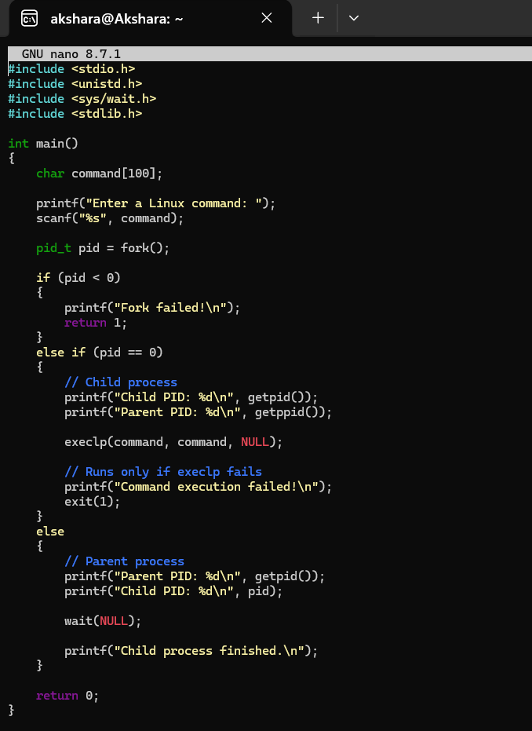
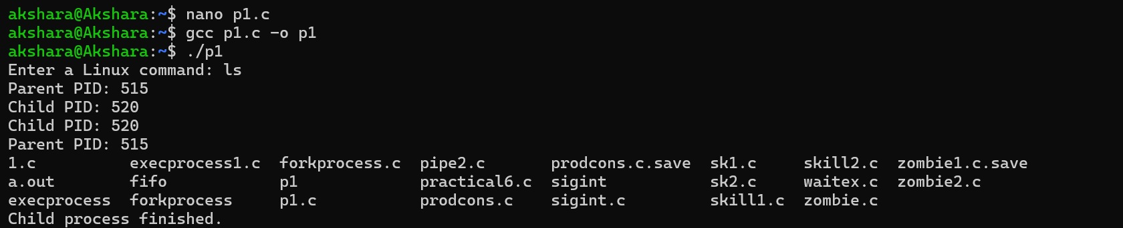
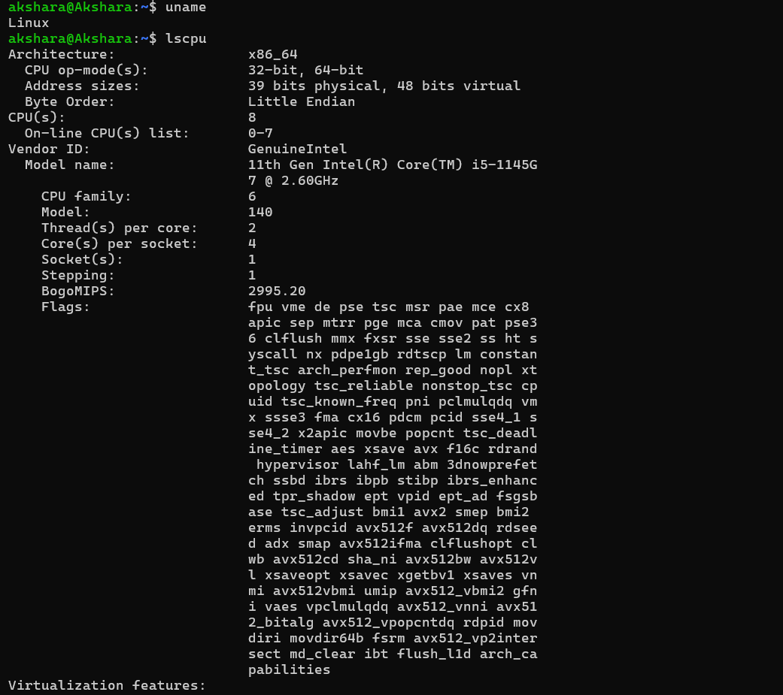
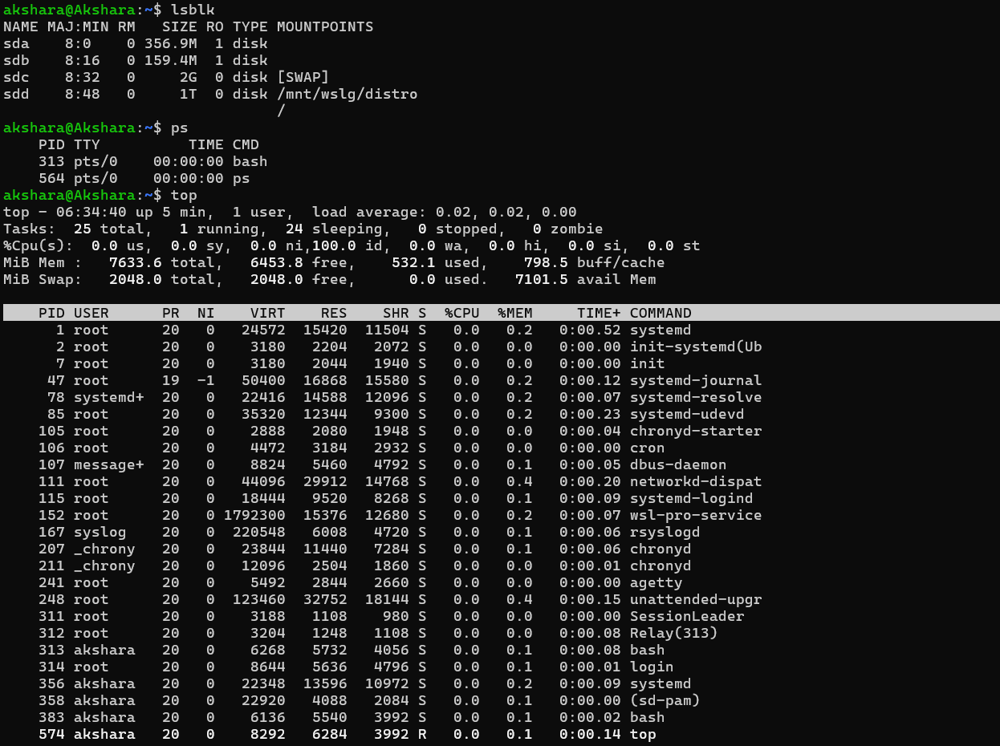
Observation Table:
Hardware Resource | Linux Command | OS Service | Abstraction
CPU | lscpu, top | CPU scheduling | Processes and threads
Memory | ps, top | Memory management | Virtual memory
Storage | lsblk | File system management | Files and directories
I/O Devices | ps, system calls | Device management | Standard I/O interface
System Information | uname | Kernel management | Operating system environment
2)
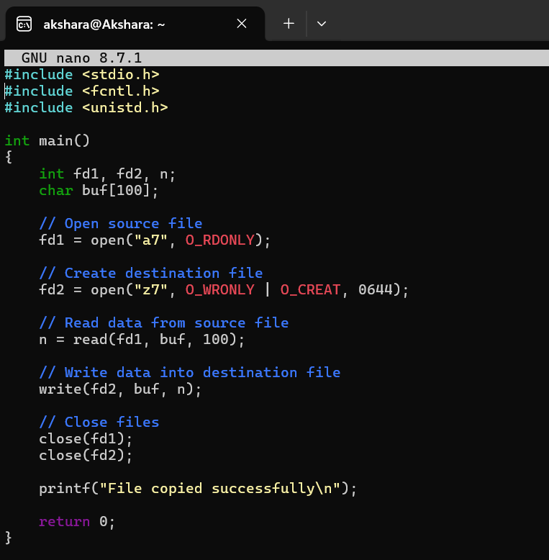
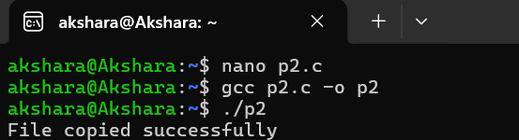
Strace:
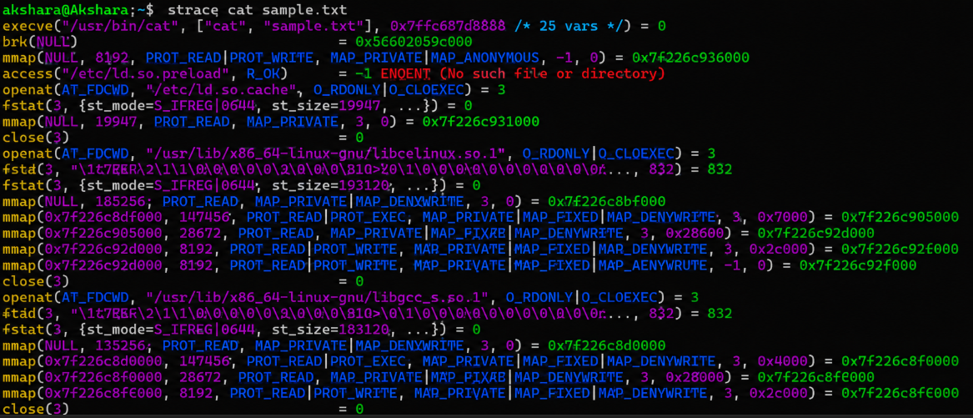
The strace command shows how a simple Linux command interacts with the kernel through system calls. When cat sample.txt is executed, the kernel loads the program, opens the file, reads its contents, writes the contents to the terminal, closes the file, and finally terminates the process.

3)
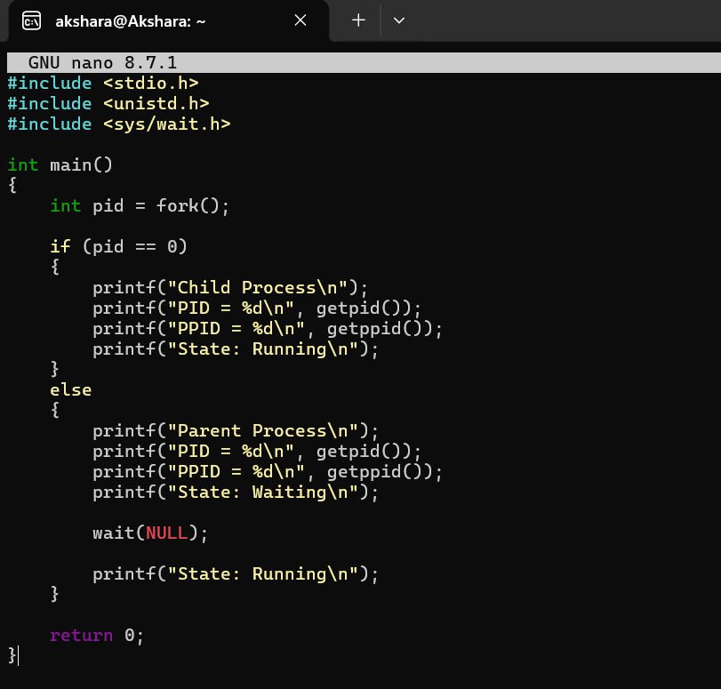
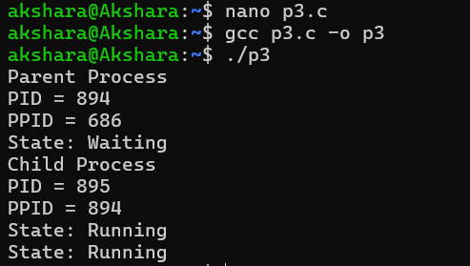
Experiment:
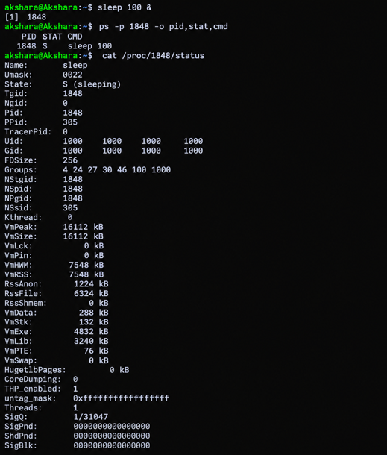

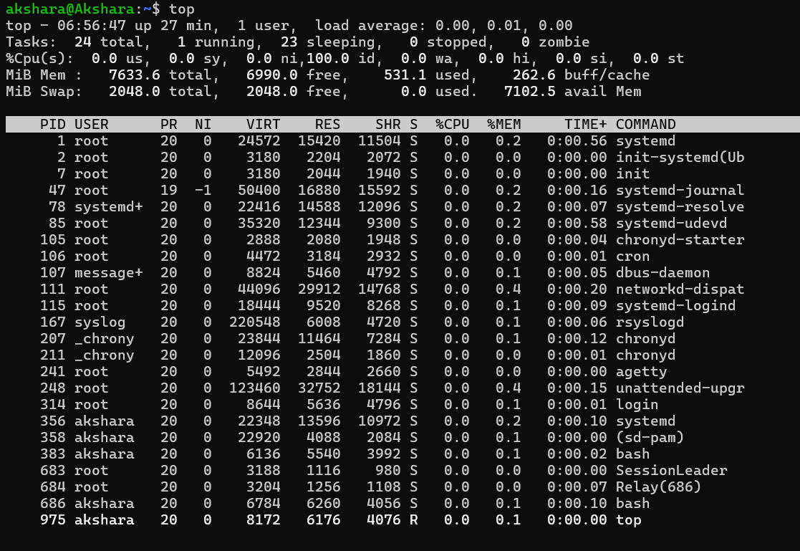
Commands Used:
- ps – Displays process information and states.
- top – Monitors processes in real time.
- /proc/PID/status – Displays detailed information about a process.
- sleep – Creates a waiting process.
- yes – Creates a CPU-intensive running process.
- kill – Terminates a process.
The experiment demonstrates different Linux process states using monitoring tools. The yes command creates a CPU-intensive process that can be observed in the R state, while the sleep command creates a process in the S or sleeping/waiting state. The ps command displays process states, top provides real-time monitoring, and /proc/PID/status provides detailed process information. Finally, the kill command terminates a process, after which it no longer appears in the process list.

